October 15, 2018

Anita Ramasastry, President
Uniform Law Commission
111 N. Wabash Avenue Suite 1010
Chicago, Illinois 60602

Dear Ms. Ramasastry,

RE: NNA Support of the 2018 Amendment to the Revised Uniform Law on Notarial Acts

The National Notary Association commends the ULC for its revisions to the Revised Uniform Law on Notarial Acts (RULONA) and recommends it to the states for enactment.

The NNA supported the RULONA when it was first adopted in 2010 (see the NNA’s letter of March 10, 2011 to then ULC President Robert A. Stein) for reasons that are as relevant today as they were then. Having been an observer of the two subsequent RULONA amendment drafting efforts in 2016 and 2018, we can now endorse the RULONA for two additional reasons.

First, the RULONA takes an industry-inclusive approach to modernizing state Notary codes. Over the NNA’s 60-year history we have observed that virtually every industry — no matter how large or small — relies on the protections of the notarial act. It takes wisdom, insight and, at times restraint, to craft a responsive and balanced Notary statute that serves all industries. The drafting committee’s decision to leave unchanged the RULONA’s interstate recognition provision relating to notarial acts performed for remotely located individuals is but one example of this.

Second, the RULONA takes a technology-neutral approach to modernizing state Notary codes. It purposely omits highly-detailed provisions that soon could become outdated and unworkable. This ensures that the statute will serve the state’s Notaries and the public they serve for years to come. The RULONA’s definitions of “communication technology” and “identity proofing” are examples of carefully defining terms to encompass existing, emerging and even future technologies. If a state wishes to add more specific provisions, the RULONA provides the mechanism through the state’s administrative rulemaking process. States may use the NNA’s Model Electronic Notarization Act to craft these more specific regulations, if it chooses.

Members of the RULONA Amendment drafting Committee, co-chaired by Patricia Brumfield Fry and Raymond P. Pepe, are to be congratulated for expanding and strengthening the RULONA of 2010.

Sincerely,
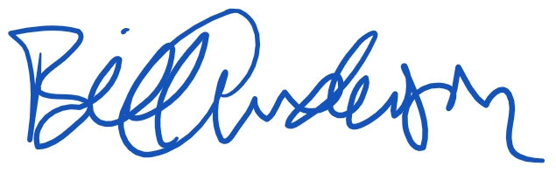

Bill Anderson
Vice President, Government Affairs

